ASSESSMENT 2 – YAZHINI S

PYTHON ASSESSMENT

Coding Assesment:

1.Explain Python Module with examples  
a.Import module in Python .Renaming the Python module

**1)PYTHON MODULE**

🡪A python module is created with .py extension.

🡪Python module is a file containing python code, which can define functions, classes and variables.

🡪It allows us to organize the code into reusable components.

🡪To use a module in another python file, we use “import” statement.

🡪Python already contains many built-in modules.

**EXAMPLE PROGRAM:**

🡪Creating a user defined module as : pythonmoduleass

🡪I have given some functions like add, sub, multi, div to perform calculations.

#pythonmoduleass.py  
def add(x,y):  
 return (x+y)  
def sub(x,y):  
 return(x-y)  
def multi(x,y):  
 return(x*y)  
def div(x,y):  
 return(x/y)

🡪Now, importing the above module and performing the functions from that module by using the values in this module.

import pythonmoduleass  
  
Addition = pythonmoduleass.add(5,3)  
Subtract = pythonmoduleass.sub(30,20)  
Multiply = pythonmoduleass.multi(9,8)  
Divide = pythonmoduleass.div(6,2)  
  
print("ADD RESULT : ",Addition)  
print("SUB RESULT : ",Subtract)  
print("MULTI RESULT : ",Multiply)  
print("DIVIDE RESULT : ", Divide)

**OUTPUT SCREENSHOT**

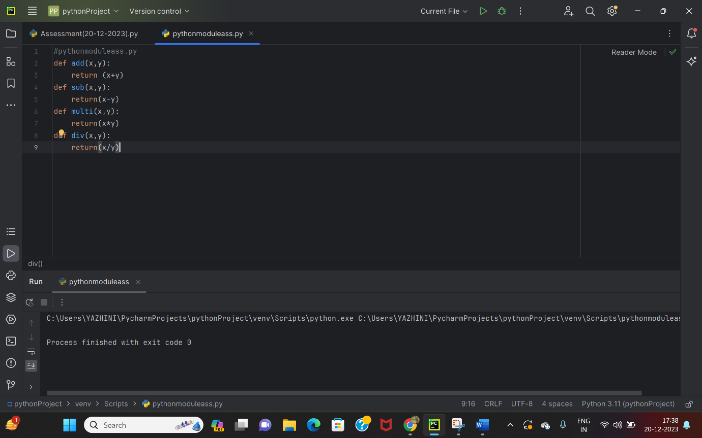

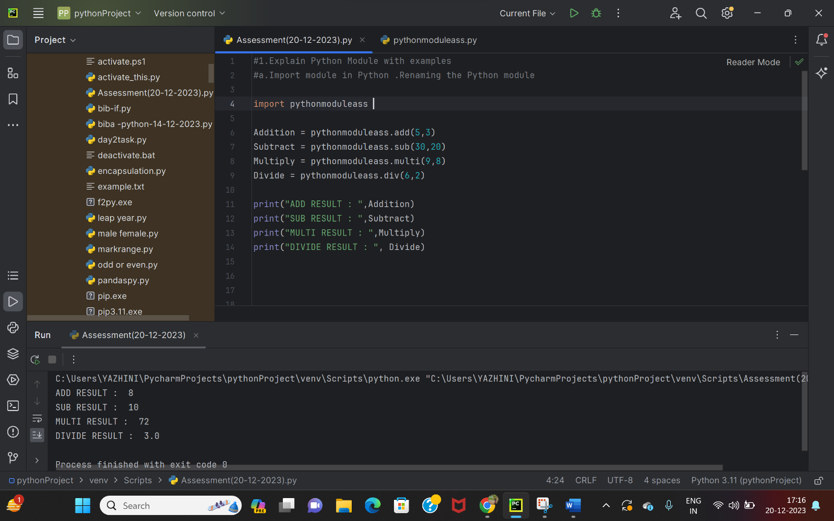

**1a) RENAMING MODULE**

**EXAMPLE PROGRAM**

🡪Here, I have renamed the module ‘ pythonmoduless’ into ‘ps’.

import pythonmoduleass as ps  
  
Addition = ps.add(5,3)  
Subtract = ps.sub(30,20)  
Multiply = ps.multi(9,8)  
Divide = ps.div(6,2)  
  
print("ADD RESULT : ",Addition)  
print("SUB RESULT : ",Subtract)  
print("MULTI RESULT : ",Multiply)  
print("DIVIDE RESULT : ", Divide)

**OUTPUT SCREENSHOT**

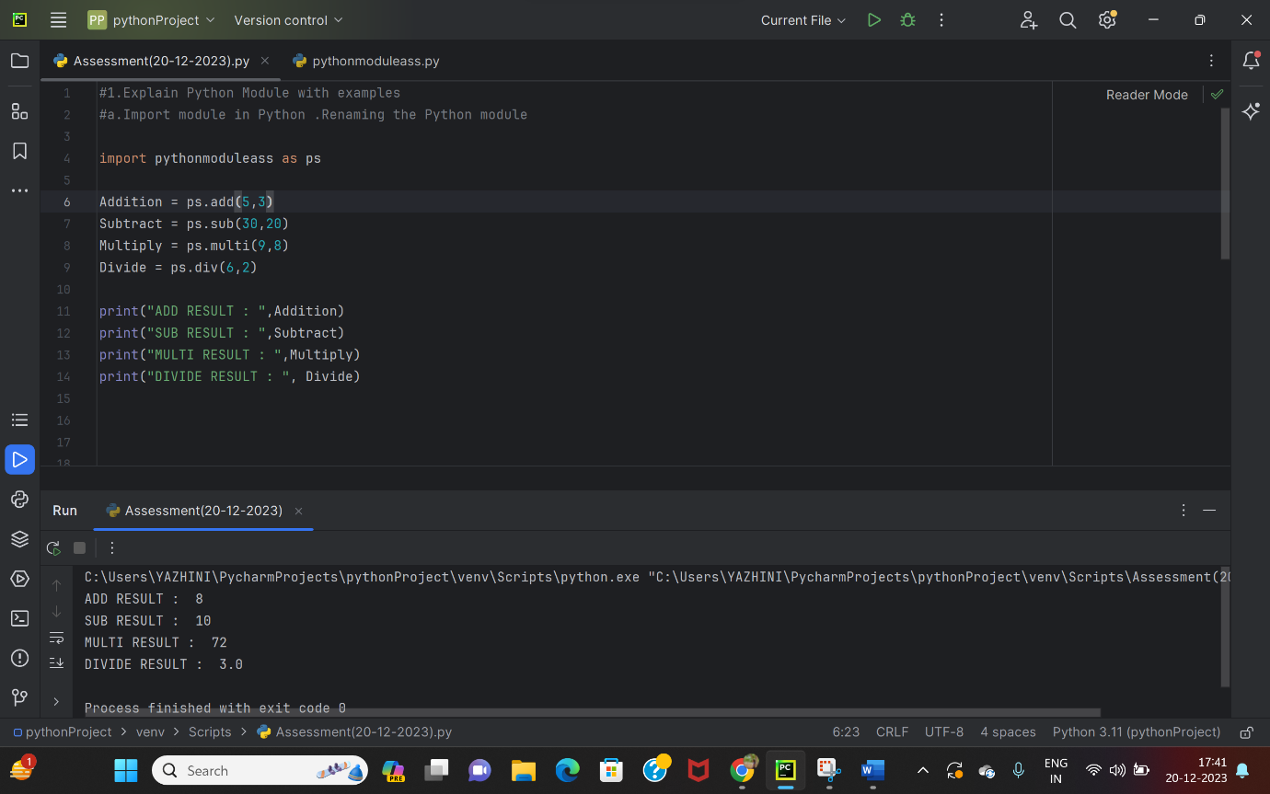

2.Explain Pandas and numpy using Examples in PYTHON

**PANDAS**

* Pandas is a open – source python library that is used to
  1. Organize Data
  2. Clean Data
  3. Analyze Data
  4. Visualize Data

🡪 Organize Data – Arrange data in way that’s easy to understand, with rows and columns.

🡪 Clean Data – Handle the missing or the messy kind of data.

🡪 Analyze Data – Perform calculations and other operations on the data.

* Visualize Data – Creates simple ways like charts ,graph etc to easily understand the data .

**EXAMPLE PROGRAM**

import pandas as ps  
data=ps.read_csv("Salary_Data.csv")  
print(data)

**OUTPUT SCREENSHOT**

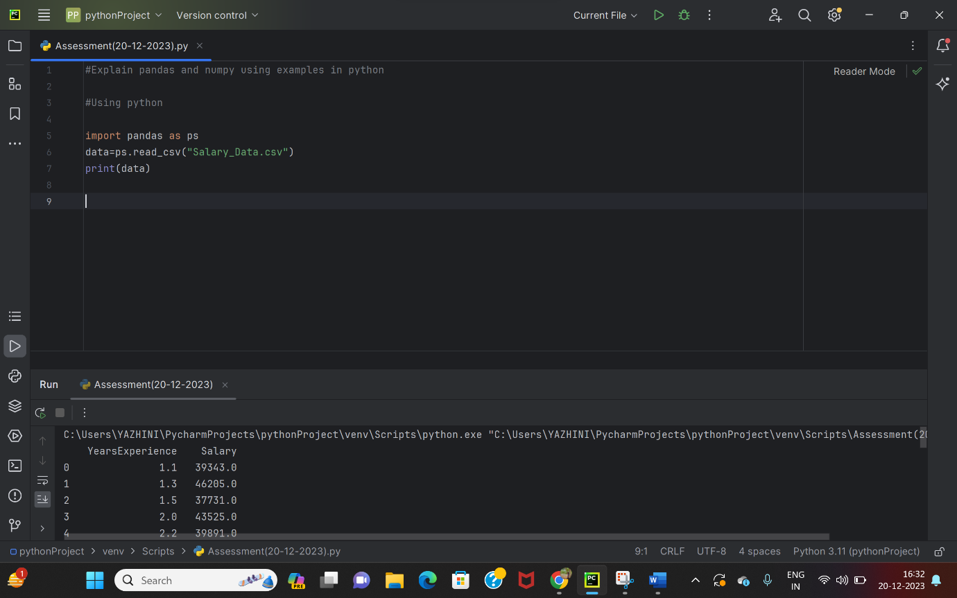

**NUMPY**

* NumPy stands for Numerical Python.

🡪 It supports for multi-dimensional arrays and matrices.

🡪 It helps to do high-level mathematical functions.

🡪 With NumPy, we can create, manipulate and perfom calculations on arrays.

**EXAMPLE PROGRAM**

import numpy as np  
  
a=np.array([3,4,5,6,7])  
b= a*2  
print(b)

**OUTPUT SCREENSHOT**

